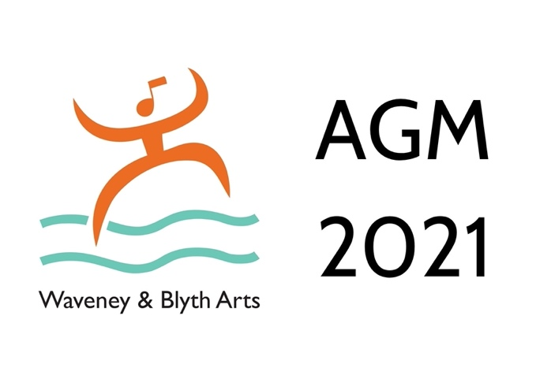
Waveney & Blyth Arts

Annual general meeting 2021

Saturday 4 December 11am at The Cut, Halesworth

AGENDA

1 Minutes of 2020 AGM

2 Financial statements and Chair’s report 2020/21
For approval

3 Report from the Recovery sub-committee

4 The future of W&BA

Proposals from the management committee:

1 That W&BA is wound up and its assets after settling outstanding liabilities, dispersed as set out in the constitution

2 That the membership be consulted about the dispersal of any remaining assets

3 That the processes required to wind up W&BA be handled by a small group comprising Ann Follows, Brian Guthrie and Jade Nice

5 Any other business

Ann Follows
11 November 2021

